Homework Classification of Metals Name Form
This website might help you! http://www.technologystudent.com/designpro/metals1.htm
Metal can be put into 3 different classifications, ferrous, non-ferrous and alloys.
Explain what ferrous means?

Suggest a way of testing whether a metal is ferrous.

Explain what non-ferrous means?

Explain what an alloy is?

Give 3 examples of products where a ferrous, non-ferrous and an alloy metal are used.
Ferrous Non-ferrous Alloy

Name a suitable, specific metal that could be used to make each of these products. Give a reason for your choice.
Drinks Can
Material Name
Reason

Bicycle Frame
Material Name
Reason

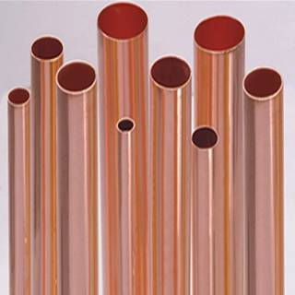
Water Pipe
Material Name
Reason

