Surface preparation &
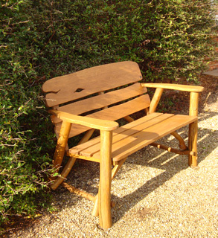
Applying a Finish to wood and metal

There are two main reasons why it is essential to apply a finish to a material.
Aesthetics: applying a finish will improve the way a product looks.
It can improve the natural look of the material or it can completely change its colour and texture.
Protection: applying a finish will protect a material from becoming damaged when in use.

Name 5 finishes that you could apply to wood.

Name 3 finishes that you would.

Write a step by step plan of how you would prepare wood before applying a finish.

