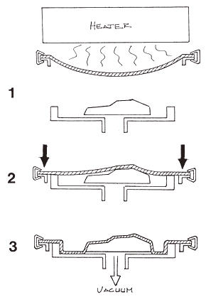

**7X DATE DUE: 29/3/11**

**7Y DATE DUE: 31/3/11**

2.

3.

4.

1.

**NAME: .**

**DATE: .**

**LEVEL: .**